An autonomous agent consists of five distinct structural layers that turn a static LLM into a dynamic system:
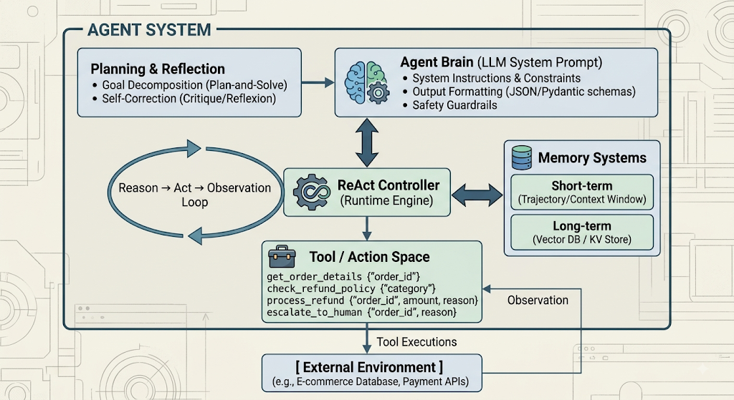
Use-Case Spec — E-Commerce Customer Support Agent
1. Specification
- Objective: Handle incoming customer support requests regarding order status, modifications, and refunds.
- Guardrails & Business Rules:
  - Auto-refund limit: Max $100.00.
  - Any request exceeding $100.00 must be escalated to a human tier-2 support agent.
  - Must verify order ownership and state before executing financial actions.

2. Available Tools
Tool Name | Input Schema | Description
get_order_details | {"order_id": "string"} | Returns order items, status, total price, and customer ID.
check_refund_policy | {"category": "string"} | Returns max auto-refund cap and policy requirements for a product type.
process_refund | {"order_id": "string", "amount": float, "reason": "string"} | Issues an immediate automated refund to the original payment method.
escalate_to_human | {"order_id": "string", "reason": "string"} | Creates a priority support ticket for human review.
Step-by-Step Decision Loop Trace (Execution Logs)
User Input:
"Hi, my jacket arrived damaged (Order #ORD-98214). I want a full refund immediately!"
==============================================================================
[AGENT LOOP INIT]
User Goal: Refund for damaged jacket on Order #ORD-98214
Max Steps: 5
==============================================================================
--- [ITERATION 1] ---
[THOUGHT]: The user wants a full refund for damaged goods on order ORD-98214.
Before taking action, I need to check the order details to find the item category, status, and total price.

[ACTION]: get_order_details
[ACTION INPUT]: {
"order_id": "ORD-98214"
}
[SYSTEM EXECUTION]: Running tool 'get_order_details'...
[OBSERVATION]: {
"status": "delivered",
"customer_id": "CUST-4412",
"total_amount": 145.00,
"items": [
{
"item_id": "SKU-99",
"name": "Leather Jacket",
"category": "Apparel",
"price": 145.00
}
]
}
--- [ITERATION 2] ---
[THOUGHT]: The order exists and was delivered. The item is a 'Leather Jacket' under category 'Apparel', and the total amount is $145.00.
Next, I must check the refund policy for 'Apparel' to confirm auto-approval thresholds and criteria.
[ACTION]: check_refund_policy
[ACTION INPUT]: {
"category": "Apparel"
}
[SYSTEM EXECUTION]: Running tool 'check_refund_policy'...
[OBSERVATION]: {
"auto_refund_limit": 100.00,
"requires_photo_proof": true,
"allowed_window_days": 30
}
--- [ITERATION 3] ---
[THOUGHT]: The policy sets the maximum auto-refund limit to $100.00 for Apparel.
The requested refund amount is $145.00, which exceeds my autonomous authority threshold of $100.00.
Per business logic guardrails, I must escalate this request to human tier-2 support rather than processing it directly.

[ACTION]: escalate_to_human
[ACTION INPUT]: {
"order_id": "ORD-98214",
"reason": "Requested refund amount of $145.00 exceeds the maximum autonomous refund limit of $100.00."
}

[SYSTEM EXECUTION]: Running tool 'escalate_to_human'...
[OBSERVATION]: {
"ticket_id": "TICK-88210",
"assigned_queue": "tier2_support",
"status": "created"
}

--- [ITERATION 4] ---
[THOUGHT]: The ticket has been created successfully. I have all necessary information to respond to the user clearly and conclude the process.

[FINAL ANSWER]:
"I have reviewed your request for Order #ORD-98214. Because the refund amount ($145.00) exceeds our automated approval limit of $100.00, I have forwarded your case directly to our Tier-2 Support Team.

Your ticket reference number is **#TICK-88210**. A representative will review the damage report and follow up with you via email within 2 business hours to finish processing your refund."

==============================================================================
[AGENT LOOP COMPLETED: SUCCESS] Total Turns: 4
==============================================================================

